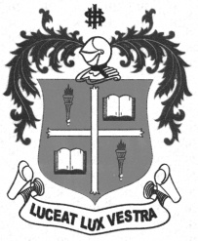
LOYOLA COLLEGE (AUTONOMOUS), CHENNAI – 600 034
M.A. DEGREE EXAMINATION - TAMIL LITERATURE
FIRST SEMESTER – NOVEMBER 2011

TL 1805 - CONTRIBUTIONS OF CHRISTIANS TO TAMIL LITT.

Date : 12-11-2011 Dept. No. Max. : 100 Marks

Time : 1:00 - 4:00


 x=
- 
- 
- 
- 
- 
- 



 x=
- 
- 
- 
- 
- 
- 



 x=
- 
- 
- 
- 

********

